**CORONAVIRUS DISEASE (COVID-19)**

**Mode of transmission:** Early reports suggest person-to-person transmission most commonly happens during close exposure to a person infected with COVID-19, primarily via respiratory droplets produced when the infected person coughs, sneezes, or talks. Droplets can land in the mouths, noses, or eyes of people who are nearby or possibly be inhaled into the lungs of those within close proximity. Recent studies indicate that people who are infected but do not have symptoms likely also play a role in the spread of COVID-19. The contribution of small respirable particles, sometimes called aerosols or droplet nuclei, to close proximity transmission is currently uncertain. However, airborne transmission from person-to-person over long distances is unlikely.

**Guidance for Healthcare Personnel (HCP)**

For the purposes of this document, HCP refers to all paid and unpaid persons serving in healthcare settings who have the potential for direct or indirect exposure to patients or infectious materials, including:

* body substances
* contaminated medical supplies, devices, and equipment
* contaminated environmental surfaces
* contaminated air

Who Needs PPE

* **Patients** with confirmed or possible SARS-CoV-2 infection should wear a facemask when being evaluated medically
* **Healthcare personnel** should adhere to Standard and Transmission-based Precautions when caring for patients with SARS-CoV-2 infection.
  1. **Adhere to Standard and Transmission-Based Precautions**

Standard Precautions assume that every person is potentially infected or colonized with a pathogen that could be transmitted in the healthcare setting.

Attention should be paid to training and proper donning (putting on), doffing (taking off), and disposal of any PPE.

HCP who enter the room of a patient with known or suspected COVID-19 should adhere to Standard Precautions and use a respirator or facemask, gown, gloves, and eye protection.

**Hand Hygiene**

* HCP should perform hand hygiene before and after all patient contact, contact with potentially infectious material, and before putting on and after removing PPE, including gloves. Hand hygiene after removing PPE is particularly important to remove any pathogens that might have been transferred to bare hands during the removal process.
* HCP should perform hand hygiene by using ABHR with 60-95% alcohol or washing hands with soap and water for at least 20 seconds. If hands are visibly soiled, use soap and water before returning to ABHR (alcohol-based hand rub).

**Personal Protective Equipment**

Any reusable PPE must be properly cleaned, decontaminated, and maintained after and between uses.

The PPE recommended when caring for a patient with known or suspected COVID-19 includes:

* **Respirator or facemask**
  + put on a respirator or facemask (if a respirator is not available) before entry into the patient room or care area.
  + n95 respirators or respirators that offer a higher level of protection should be used instead of a facemask when performing or present for an aerosol-generating procedure. disposable respirators and facemasks should be removed and discarded after exiting the patient’s room or care area and closing the door. perform hand hygiene after discarding the respirator or facemask. for guidance on extended use of respirators, refer to
  + if reusable respirators are used, they must be cleaned and disinfected according to manufacturer’s reprocessing instructions prior to re-use.
* **Eye Protection**
  + Put on eye protection (i.e., goggles or a disposable face shield that covers the front and sides of the face) upon entry to the patient room or care area. Personal eyeglasses and contact lenses are NOT considered adequate eye protection.
  + Remove eye protection before leaving the patient room or care area.
  + Reusable eye protection (e.g., goggles) must be cleaned and disinfected according to manufacturer’s reprocessing instructions prior to re-use. Disposable eye protection should be discarded after use.
* **Gloves**
  + Put on clean, non-sterile gloves upon entry into the patient room or care area.
    - Change gloves if they become torn or heavily contaminated.
  + Remove and discard gloves when leaving the patient room or care area, and immediately perform hand hygiene.
* **Gowns**
  + Put on a clean isolation gown upon entry into the patient room or area. Change the gown if it becomes soiled. Remove and discard the gown in a dedicated container for waste or linen before leaving the patient room or care area. Disposable gowns should be discarded after use. Cloth gowns should be laundered after each use.
  + If there are shortages of gowns, they should be prioritized for:
    - aerosol-generating procedures
    - care activities where splashes and sprays are anticipated
    - high-contact patient care activities that provide opportunities for transfer of pathogens to the hands and clothing of HCP. Examples include:
      * dressing
      * bathing/showering
      * transferring
      * providing hygiene
      * changing linens
      * changing briefs or assisting with toileting
      * device care or use
      * wound care

### **How to Put On (Don) PPE Gear**

More than one donning method may be acceptable. Training and practice using your healthcare facility’s procedure is critical. Below is one example of donning.

1. **Identify and gather the proper PPE to don.** Ensure choice of gown size is correct (based on training).
2. **Perform hand hygiene using hand sanitizer.**
3. P**ut on isolation gown.** Tie all of the ties on the gown. Assistance may be needed by other healthcare personnel.
4. **Put on NIOSH-approved N95 filtering facepiece respirator or higher (use a facemask if a respirator is not available).** If the respirator has a nosepiece, it should be fitted to the nose with both hands, not bent or tented. Do not pinch the nosepiece with one hand. Respirator/facemask should be extended under chin. Both your mouth and nose should be protected. Do not wear respirator/facemask under your chin or store in scrubs pocket between patients.*
   * **Respirator:** Respirator straps should be placed on crown of head (top strap) and base of neck (bottom strap). Perform a user seal check each time you put on the respirator.
   * **Facemask:** Mask ties should be secured on crown of head (top tie) and base of neck (bottom tie). If mask has loops, hook them appropriately around your ears.
5. **Put on face shield or goggles.** Face shields provide full face coverage. Goggles also provide excellent protection for eyes, but fogging is common.
6. **Perform hand hygiene before putting on gloves.** Gloves should cover the cuff (wrist) of gown.
7. **Healthcare personnel may now enter patient room.**

[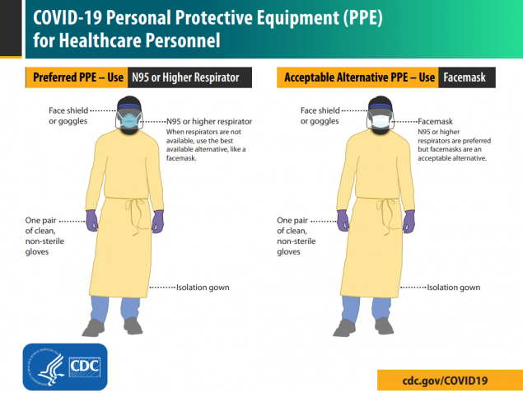](https://www.google.co.uk/url?sa=i&url=https%3A%2F%2Fwww.cdc.gov%2Fcoronavirus%2F2019-ncov%2Fhcp%2Fusing-ppe.html&psig=AOvVaw30QiJnpVNGAu4CQYK7PtZE&ust=1586523098279000&source=images&cd=vfe&ved=0CAIQjRxqFwoTCLiR3KKx2-gCFQAAAAAdAAAAABAD)

* 1. **Patient placement**

**Interim Guidance for Implementing Home Care of People Not Requiring Hospitalization for Coronavirus Disease 2019 (COVID-19)**

This interim guidance is for healthcare personnel who are coordinating the home care and isolation of people with confirmed or suspected COVID-19

infection, including persons under investigation. This includes patients evaluated in an outpatient setting who do not require hospitalization (i.e., patients who are medically stable and can receive care at home) or patients who are discharged home following a hospitalization with confirmed COVID-19 infection.

In general, people should adhere to home isolation until the risk of secondary transmission is thought to be low.

**Assess the Suitability of the Residential Setting for Home Care**

Considerations for care at home include whether:

* The patient is stable enough to receive care at home.
* Appropriate caregivers are available at home.
* There is a separate bedroom where the patient can recover without sharing immediate space with others.
* Resources for access to food and other necessities are available.
* The patient and other household members have access to appropriate, recommended personal protective equipment (at a minimum, gloves and facemask) and are capable of adhering to precautions recommended as part of home care or isolation (e.g., respiratory hygiene and cough etiquette, hand hygiene);
* There are household members who may be at increased risk of complications from COVID-19 infection (. e.g., people >65 years old, young children, pregnant women, people who are immunocompromised or who have chronic heart, lung, or kidney conditions).

[**Interim Guidance for Preventing Coronavirus Disease 2019 (COVID-19) from Spreading to Others in Homes and Communities**](https://www.cdc.gov/coronavirus/2019-ncov/hcp/guidance-prevent-spread.html)**to the patient, caregiver, and household members**

**Follow the steps below:**  If you are sick with COVID-19 or think you might have COVID-19, follow the steps below to care for yourself and to help protect other people in your home and community.

Stay home except to get medical care

* **Stay home:** Most people with COVID-19 have mild illness and are able to recover at home without medical care. Do not leave your home, except to get medical care. Do not visit public areas.
* **Stay in touch with your doctor**. Call before you get medical care. Be sure to get care if you have trouble breathing, or have any other [emergency warning signs](https://www.cdc.gov/coronavirus/2019-ncov/if-you-are-sick/steps-when-sick.html#warning-signs), or if you think it is an [emergency](https://www.cdc.gov/coronavirus/2019-ncov/if-you-are-sick/steps-when-sick.html#emergency).
* **Avoid public transportation:** Avoid using public transportation, ridesharing, or taxis.
* Separate yourself from other people and pets in your home, this is known as home isolation
* **Stay away from others:** As much as possible, stay away from others. You should stay in a specific “sick room” if possible, and away from other people and pets in your home. Use a separate bathroom, if available.

Call ahead before visiting your doctor

* **Call ahead:** Many medical visits for routine care are being postponed or done by phone or telemedicine.
* If you have a medical appointment that cannot be postponed, call your doctor’s office, and tell them you have or may have COVID-19. This will help the office protect themselves and other patients.

If you are sick wear a cloth covering over your nose and mouth

* You should wear a [cloth face covering,](https://www.cdc.gov/coronavirus/2019-ncov/prevent-getting-sick/cloth-face-cover.html) over your nose and mouth if you must be around other people even at home).

**Note**: During the COVID-19 pandemic, medical grade facemasks are reserved for healthcare workers and some first responders. You may need to improvise a cloth face covering using a scarf or bandana.

Cover your coughs and sneezes

* **Cover:** Cover your mouth and nose with a tissue when you cough or sneeze.
* **Dispose:** Throw used tissues in a lined trash can.
* **Wash hands:** Immediately wash your hands with soap and water for at least 20 seconds. If soap and water are not available, clean your hands with an alcohol-based hand sanitizer that contains at least 60% alcohol.

Clean your hands often

* **Wash hands:** Wash your hands often with soap and water for at least 20 seconds. This is especially important after blowing your nose, coughing, or sneezing; going to the bathroom; and before eating or preparing food.
* **Hand sanitizer:** If soap and water are not available, use an alcohol-based hand sanitizer with at least 60% alcohol, covering all surfaces of your hands and rubbing them together until they feel dry.
* **Soap and water:** Soap and water are the best option, especially if hands are visibly dirty.
* **Avoid touching:** Avoid touching your eyes, nose, and mouth with unwashed hands.

Avoid sharing personal household items

* **Do not share:** Do not share dishes, drinking glasses, cups, eating utensils, towels, or bedding with other people in your home.
* **Wash thoroughly after use:** After using these items, wash them thoroughly with soap and water or put in the dishwasher.

Clean all “high-touch” surfaces everyday

Clean high-touch surfaces in your isolation area (“sick room” and bathroom) every day; let a caregiver clean and disinfect high-touch surfaces in other areas of the home.

* **Clean and disinfect:** Routinely clean high-touch surfaces in your “sick room” and bathroom. Let someone else clean and disinfect surfaces in common areas, but not your bedroom and bathroom.
  + If a caregiver or other person needs to clean and disinfect a sick person’s bedroom or bathroom, they should do so on an as-needed basis. The caregiver/other person should wear a mask and wait as long as possible after the sick person has used the bathroom.

High-touch surfaces include phones, remote controls, counters, tabletops, doorknobs, bathroom fixtures, toilets, keyboards, tablets, and bedside tables.

* **Clean and disinfect areas that may have blood, stool, or body fluids on them**.
* **Household cleaners and disinfectants:** Clean the area or item with soap and water or another detergent if it is dirty. Then, use a household disinfectant.
  + Be sure to follow the instructions on the label to ensure safe and effective use of the product. Many products recommend keeping the surface wet for several minutes to ensure germs are killed. Many also recommend precautions such as wearing gloves and making sure you have good ventilation during use of the product.

Monitor your symptoms

* Common symptoms of COVID-19 include fever and cough. Trouble breathing is a more serious symptom that means you should get medical attention.
* **If you are having trouble breathing, seek medical attention, but call first.** 
  + Call your doctor or emergency room before going in and tell them your symptoms. They will tell you what to do.
* **Wear a cloth face covering (covers your nose and mouth):** Put on the cloth face covering when you leave your house or when around other people. You don’t need to wear the cloth face covering if you are alone. If you can’t put on a cloth face covering (because of trouble breathing for example), cover your coughs and sneezes in some other way. Try to stay at least 6 feet away from other people. This will help protect the people around you.
* **Follow care instructions from your healthcare provider and local health department:** Your local health authorities may give instructions on checking your symptoms and reporting information.

**When to Seek Medical Attention**

If you develop emergency warning signs for COVID-19 get medical attention immediately. Emergency warning signs include*:

* Trouble breathing
* Persistent pain or pressure in the chest
* New confusion or inability to arouse
* Bluish lips or face

*This list is not all inclusive. Please consult your medical provider for any other symptoms that are severe or concerning.

**How to discontinue home isolation**

People **with COVID-19 who have stayed home (home isolated)** can stop home isolation under the following conditions:

* **If you will not have a test** to determine if you are still contagious, you can leave home after these three things have happened:
  + You have had no fever for at least 72 hours (that is three full days of no fever without the use medicine that reduces fevers)  
    AND
  + other symptoms have improved (for example, when your cough or shortness of breath have improved)  
    AND
  + at least 7 days have passed since your symptoms first appeared
* **If you will be tested** to determine if you are still contagious, you can leave home after these three things have happened:
  + You no longer have a fever (without the use medicine that reduces fevers)  
    AND
  + other symptoms have improved (for example, when your cough or shortness of breath have improved)  
    AND
  + You received two negative tests in a row, 24 hours apart. Your doctor will follow

In all cases, **follow the guidance of your healthcare provider and local health department.** The decision to stop home isolation should be made in consultation with your healthcare provider and state and local health departments. Local decisions depend on local circumstance.

[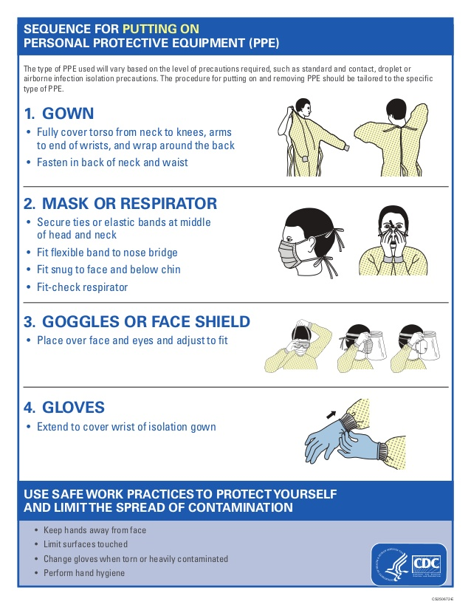](https://www.google.co.uk/url?sa=i&url=https%3A%2F%2Fwww.slideshare.net%2FHanadiAlbasha%2Fpersonal-protective-equipment-sequence&psig=AOvVaw1ijknx2_C5TB8NZ5OMOdiB&ust=1586512948121000&source=images&cd=vfe&ved=0CAIQjRxqFwoTCOisvriL2-gCFQAAAAAdAAAAABAD)

* Doffing
  + Removing used PPE is a high-risk process that requires a structured procedure, a trained observer, a doffing assistant in some situations, and a designated area for removal to ensure protection.
  + PPE must be removed slowly and deliberately in the correct sequence to reduce the possibility of self-contamination or other exposure to Ebola.
  + A stepwise process should be developed and used during training and patient care.

[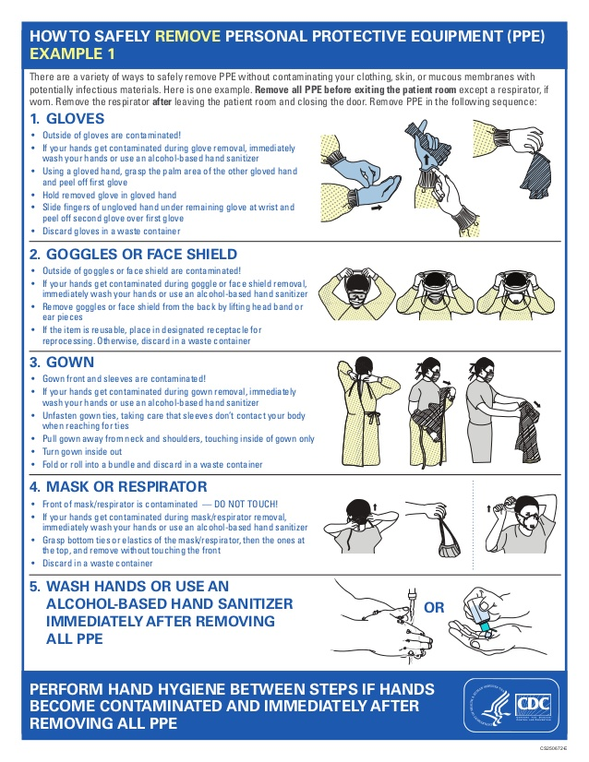](https://www.google.co.uk/url?sa=i&url=https%3A%2F%2Fwww.slideshare.net%2FHanadiAlbasha%2Fpersonal-protective-equipment-sequence&psig=AOvVaw3jvzPLcHCZuX6JMGcIYOUE&ust=1586513140025000&source=images&cd=vfe&ved=0CAIQjRxqFwoTCLiMtJSM2-gCFQAAAAAdAAAAABAI)

## Training on Correct Use of PPE

Training ensures that healthcare provider is knowledgeable and proficient in donning and doffing PPE before caring for a patient with Covid-19. Comfort and proficiency when donning and doffing are only achieved by repeatedly practicing correct use of PPE. Healthcare provider should be required to demonstrate competency in using PPE, including donning and doffing while being observed by a trained observer, before working with patients with Covid-19. In addition, during practice, healthcare provider and their trainers should assess proficiency and comfort with performing required duties while wearing PPE. People unwilling or unable to fulfill these requirements should not care for a patient with Covid-19.

HOW TO CLEAN AND DISINFECT:

##### **hard (non-porous) surfaces**

* wear disposable gloves when cleaning and disinfecting surfaces. gloves should be discarded after each cleaning. if reusable gloves are used, those gloves should be dedicated for cleaning and disinfection of surfaces for covid-19 and should not be used for other purposes. [clean hands](https://www.cdc.gov/handwashing/when-how-handwashing.html) immediately after gloves are removed.
* If surfaces are dirty, they should be cleaned using a detergent or soap and water prior to disinfection.
* for disinfection, most common epa-registered household disinfectants should be effective.
  + Follow manufacturer’s instructions for all cleaning and disinfection products for (concentration, application method and contact time, etc.).
  + additionally, diluted household bleach solutions can be used if appropriate for the surface. follow manufacturer’s instructions for application, ensuring a contact time of at least 1 minute, and allowing proper ventilation during and after application. check to ensure the product is not past its expiration date. never mix household bleach with any other cleanser. unexpired household bleach will be effective against coronaviruses when properly diluted.
* prepare a bleach solution by mixing:
  + 5 tablespoons (1/3rd cup) bleach per gallon of water or
  + 4 teaspoons bleach per quart of water

##### **soft (porous) surfaces**

* For soft (porous) surfaces such as carpeted floor, rugs, and drapes, remove visible contamination if present and clean with appropriate cleaners indicated for use on these surfaces. after cleaning:
  + launder items as appropriate in accordance with the manufacturer’s instructions. if possible, launder items using the warmest appropriate water setting for the items and dry items completely.
    - otherwise, use products [that are epa-approved for use against the virus that causes covid-19pdf iconexternal icon](https://www.epa.gov/sites/production/files/2020-03/documents/sars-cov-2-list_03-03-2020.pdf) and that are suitable for porous surfaces.

##### **electronics**

* for electronics such as cell phones, tablets, touch screens, remote controls, and keyboards, remove visible contamination if present.
  + follow the manufacturer’s instructions for all cleaning and disinfection products.
  + consider use of wipeable covers for electronics.
  + if no manufacturer guidance is available, consider the use of alcohol-based wipes or sprays containing at least 70% alcohol to disinfect touch screens. dry surfaces thoroughly to avoid pooling of liquids.

##### **linens, clothing, and other items that go in the laundry**

* wear disposable gloves when handling dirty laundry from an ill person and then discard after each use. if using reusable gloves, those gloves should be dedicated for cleaning and disinfection of surfaces for covid-19 and should not be used for other household purposes. [clean hands](https://www.cdc.gov/handwashing/when-how-handwashing.html) immediately after gloves are removed.
  + if no gloves are used when handling dirty laundry, be sure to wash hands afterwards.
  + if possible, do not shake dirty laundry. this will minimize the possibility of dispersing virus through the air.
  + launder items as appropriate in accordance with the manufacturer’s instructions. if possible, launder items using the warmest appropriate water setting for the items and dry items completely. dirty laundry from an ill person can be washed with other people’s items.
  + clean and disinfect clothes hampers according to guidance above for surfaces. if possible, consider placing a bag liner that is either disposable (can be thrown away) or can be laundered.

hand hygiene and other preventive measures

* household members should [clean hands](https://www.cdc.gov/handwashing/when-how-handwashing.html) often, including immediately after removing gloves and after contact with an ill person, by washing hands with soap and water for 20 seconds. if soap and water are not available and hands are not visibly dirty, an alcohol-based hand sanitizer that contains at least 60% alcohol may be used. however, if hands are visibly dirty, always wash hands with soap and water.
* household members should follow normal preventive actions while at work and home including recommended [hand hygiene](https://www.cdc.gov/handwashing/when-how-handwashing.html) and avoiding touching eyes, nose, or mouth with unwashed hands.
  + additional key times to clean hands include:
    - after blowing one’s nose, coughing, or sneezing
    - after using the restroom
    - before eating or preparing food
    - after contact with animals or pets
    - before and after providing routine care for another person who needs assistance (e.g. a child)

**other considerations**

* the ill person should eat/be fed in their room if possible. non-disposable food service items used should be handled with gloves and washed with hot water or in a dishwasher. [clean hands](https://www.cdc.gov/handwashing/when-how-handwashing.html) after handling used food service items
* garbage bags, handling, and disposing of trash. [wash hands](https://www.cdc.gov/handwashing/when-how-handwashing.html) after handling or disposing of trash.
* consider consulting with your local health department about trash disposal guidance if available.

# Disinfectants for Use Against SARS-CoV-2

**All products on this list** meet EPA’s criteria for use against SARS-CoV-2, the virus that causes COVID-19.

**List N was last updated on April 2, 2020.**

**https://www.epa.gov/pesticide-registration/list-n-disinfectants-use-against-sars-cov-2**